Agentic AI Applications Course Project Proposal
Team Number:
Team Member Name(s): 1.Abhijna YM(R23EA004)
2. Aishwarya C Gujjar(R23EA011)
3.Disha D Naik(R23EA035)
4.Harshini GS(R23EA047)

Proposed Project Title:
ClosetMind: An Agentic AI-Based Autonomous Wardrobe Planning and Outfit Recommendation System

1. Problem Statement & Use Case
In today’s fast-paced academic and professional environments, individuals often experience decision fatigue when selecting outfits. Despite owning multiple clothing items, users struggle to efficiently plan combinations suitable for weather, occasions, mood, and prior outfit history.
The system addresses the following problems:
- Repetitive outfit usage due to lack of tracking
- Time wasted in daily decision-making
- Underutilization of wardrobe items
- Impulsive or redundant clothing purchases
- Poor coordination between weather, event type, and clothing suitability
Target Users:
- College students
- Working professionals
- Fashion-conscious individuals
- Budget-conscious users
Existing solutions such as inspiration boards and generic fashion apps do not understand the user's actual wardrobe, lack memory, and cannot perform structured planning. Therefore, a multi-agent autonomous AI system is required.

2. Justification of Agentic Nature
Core Agentic Capabilities Required:
- Tool usage (vision model, weather API, calendar API, database queries)
- Planning and task decomposition
- Persistent memory (wardrobe + outfit history)
- Reflection and self-correction
- Multi-agent coordination
A single LLM prompt would fail to maintain long-term memory, perform structured planning, avoid repetition, and integrate tool-based verification. The proposed system requires autonomous reasoning and iterative correction.

3. High-Level Solution Overview
Main Agents and Roles:
1. Wardrobe Analyzer Agent – Classifies clothing and extracts metadata.
2. Styling Agent – Generates context-aware outfit combinations.
3. Planner Agent – Creates structured weekly plans.
4. Reflection Agent – Validates combinations and corrects errors.
5. Coordinator Agent – Manages workflow execution.
High-Level Workflow:
User Uploads Images → Wardrobe Analyzer → Database Storage → Planner Agent → Styling Agent → Reflection Agent → Final Output

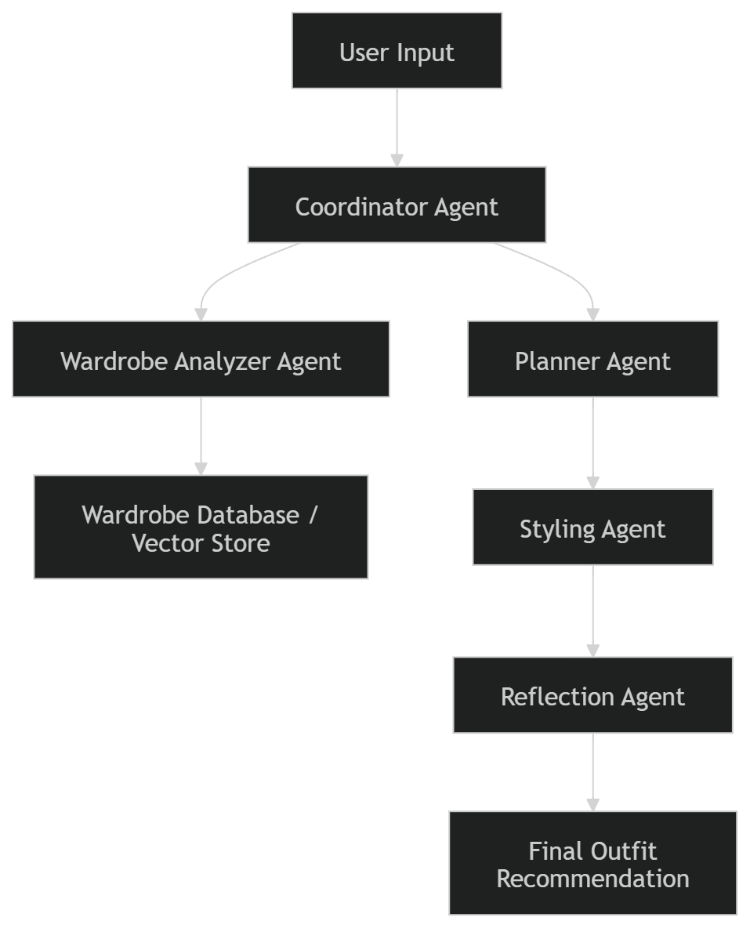

4. Proposed Technology Stack
4.1 LLM Provider and Model Selection
The primary large language model used in this project will be OpenAI GPT-4o (or GPT-4.1).
This model is selected because:
- It provides strong multi-step reasoning capabilities.
- It supports tool invocation and structured function calling.
- It enables reflection-based self-correction loops.
- It supports multimodal input (text + image understanding), which is essential for wardrobe analysis.
For cost-sensitive tasks such as lightweight classification or intermediate reasoning, smaller variants (e.g., GPT-4o-mini) may be used.
4.2 Core Agent Framework
The system will be implemented using LangGraph as the primary agent orchestration framework.
LangGraph is chosen because it:
- Supports multi-agent workflows.
- Enables stateful execution and memory persistence.
- Allows structured control of agent coordination.
- Supports reflection loops and iterative planning.
The framework will manage communication between the Wardrobe Analyzer Agent, Styling Agent, Planner Agent, and Reflection Agent.

4.3 Vision and Image Processing
To analyze user-uploaded clothing images, the system will use:
- OpenAI Vision API (primary choice), or
- CLIP (Contrastive Language–Image Pretraining) for embedding-based classification.
These models will be used to:
- Classify clothing type (top, bottom, footwear, ethnic, formal, casual).
- Extract dominant colors.
- Identify patterns and season suitability.
- Generate embeddings for semantic similarity matching.
4.4 Databases and Memory Management
The system will incorporate both structured and vector-based memory.
Structured Database:
- SQLite (for MVP implementation)
- MongoDB (for scalable version)
This database will store:
- Clothing metadata
- Outfit history
- User preferences
- Event records
Vector Database:
- ChromaDB
The vector database will store:
- Clothing embeddings
- Semantic representations for outfit matching
- Long-term wardrobe memory
This hybrid memory strategy ensures both symbolic storage and semantic reasoning capability.

4.5 External APIs and Tools
The system will integrate the following tools:
- Weather API (e.g., OpenWeatherMap) to adapt outfit suggestions based on temperature and rain conditions.
- Calendar API (optional) to align outfits with scheduled events.
- Custom color harmony scoring functions to evaluate outfit compatibility.
- Outfit repetition detection logic to avoid recently worn combinations.
These tools enable real-world contextual awareness and enhance autonomous decision-making.

4.6 Backend Implementation
The backend will be developed using:
- Python (primary programming language)
- FastAPI (for building REST APIs and agent endpoints)
FastAPI is selected due to its lightweight architecture, high performance, and compatibility with modern AI frameworks.

4.7 Frontend / User Interface
Two frontend options are considered:
- Streamlit (for rapid MVP development and demo purposes), or
- React (with Tailwind CSS) for a more polished and scalable web interface.
The frontend will support:
- Clothing image upload
- Wardrobe dashboard visualization
- Outfit recommendation display
- Weekly planning interface

4.8 Evaluation and Monitoring Tools
To evaluate system performance, the following tools will be used:
- LangSmith for agent trace monitoring and debugging.
- Custom evaluation scripts for task success measurement.
- Manual scoring rubric for qualitative assessment.
Key metrics tracked will include:
- Task success rate
- Tool invocation accuracy
- Reflection correction rate
- Latency and response time
4.9 Deployment Strategy
The system will be deployed using:
- Hugging Face Spaces or Render for backend hosting.
- Vercel (if React frontend is used).
This deployment approach ensures accessibility, scalability, and ease of demonstration during evaluations.

5. Success Metrics & Evaluation Plan
Quantitative Metrics:
- Task Success Rate ≥ 85%
- Repetition Avoidance Accuracy ≥ 90%
- Response Time ≤ 8 seconds
- Tool Invocation Accuracy ≥ 85%
Qualitative Evaluation:
User study (5–10 participants) evaluating relevance, style satisfaction, and explanation clarity.

6. Risks, Challenges & Mitigation Plan

Developing an agentic AI system such as ClosetMind involves several technical and operational challenges. The key risks and mitigation strategies are summarized below.
6.1 Vision Model Inaccuracy
Risk:
The clothing classification model may incorrectly identify clothing type, color, or pattern, affecting outfit recommendations.
Mitigation:
- Use confidence thresholds for predictions.
- Allow users to manually edit wardrobe metadata.
- Re-validate classifications where necessary.

6.2 Excessive Reflection Loops and High Latency
Risk:
The reflection agent may repeatedly regenerate outputs due to strict constraints, increasing response time and API cost.
Mitigation:
- Limit reflection to a maximum of 2–3 iterations.
- Use scoring thresholds to accept satisfactory outputs early.
- Monitor token usage and optimize prompts.

6.3 External API or Tool Failures
Risk:
Weather APIs or other external tools may fail temporarily, impacting decision-making.
Mitigation:
- Implement fallback default values.
- Add error-handling logic within the agent workflow.
- Ensure graceful degradation instead of system failure.

6.4 Scope Management
Risk:
The project may expand beyond manageable limits due to additional feature ideas.
Mitigation:
- Define a strict MVP (wardrobe upload, single outfit generation, weekly planner, reflection loop).
- Follow milestone-based development.

7. Timeline & Milestones
Demo 1: Single-agent prototype + classification working
Mid Submission: Multi-agent + reflection loop
Demo 2: Weekly planner + user testing
Final: Fully deployed and evaluated system

